**Astronomy&Astrophysics(Caucasus) 8,(2024)**

**Physical characteristics of the surfaces of Jupiter's Galilean moons**

**Revaz Chigladze**

**Samtskhe-Javakheti State University, Georgia;**

**E-mail: revazchigladze@yahoo.com.**

**Summary:**

Since 1981, the E. Kharadze Georgian National Astrophysical Observatory has been conducting polarimetric (P) and photometric (M) observations of Jupiter's Galilean moons with telescopes of different diameters (40-cm and 125-cm), as well as polarimeter Automatic Scanning Electron Polarimeter (ASEP)-78, the latest generation photometer with polarimeter and modern light receiver Santana Barbara Instrument Group (SBIG). As it turns out from the analysis of the observed material, parameters P and M depend on: α, the phase angle of the moon (satellite); L, the orbital latitude of the moon (satellite); λ, the wavelength, and t, the period of observation, i.e., $P = P (α, L, λ, t)$, and similarly: $M = M (α, L, λ, t).$ Based on the analysis of the obtained results, we get: The magnitude of the degree of polarization of Jupiter's Galilean moons near the opposition significantly differs from zero. Europa appears to have the most uniform surface, and Callisto has the least. Time variations are most characteristic of Io, which confirms the presence of volcanic activity on its surface. Based on the observed materials, it can be seen that the intensity of light reflected from the front hemisphere of the first three moons: Io, Europa, and Ganymede, is less than the intensity of light reflected from the rear hemisphere, while the picture with Callisto is opposite. The paper provides an explanation of this fact.

***Keywords****:* Galilean moons, polarization, degree of polarization, photometry.

**I. Topic relevance:**

At present, one of the most relevant topics is the utilization of near space, in particular, in the last period, the interest in the in-depth study of planetary satellites and asteroids has increased significantly, as we have been given the opportunity to examine them in a complex way using ground-based telescopes and space missions.

For the first time in this direction, we studied the Moon, its surface facing us, and finally published a multi-parameter lunar atlas. Thus, experience was accumulated and we started studying the Galilean satellites of Jupiter.

Long-term photometric and polarimetric observations of the surfaces of Jupiter's Galilean moons (Io, Europa, Ganymede, and Callisto) have shown that their surfaces differ from each other. I will refer to the drawing to show this.

For more clarity, we refer to the schematic image in Fig. 1, where: P depending on α –phase angle, L - orbital longitude, λ - wave length and t - observation period, or $P = P (α, L, λ, t)$ and similarly: $M = M (α, L, λ, t)[1-5]$.

**II.Research methods:**

The research methodology includes: 1) Observations by means spectrophotometry and spectropolarimetry; 2) Data analysis and search for correlations; 3) Comparative analysis with the data for other Solar system bodies.

From the analysis of the results obtained, the following conclusions can be drawn:

1. The value of the degree of polarization of the light reflected from the front hemisphere of Io (in the direction of movement) is 0.27% lower the value of the degree of polarization of the light reflected from the back hemisphere.
2. The value of the degree of polarization of the light reflected from the front hemisphere of Europa is 0.15% lower than the value of the degree of polarization of the light reflected
3. The value of the degree of polarization of the light reflected from the front hemisphere of Ganymede is 0.35% lower than the value of the degree of polarization of the light reflected from the back hemisphere.
4. The value of the degree of polarization of the light reflected from the front hemisphere of Callisto is 0.67% higher than the value of the degree of polarization of the light reflected from the rear hemisphere.

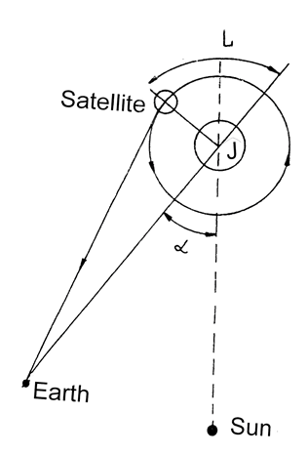

**Fig. 1 Schematic picture**

**III.Analysis**

It is evident that the magnitude of the degree of polarization of the light reflected from the front hemisphere of the first three satellites (Io, Europa, Ganymede) is less than the degree of polarization of the light reflected from the rear hemisphere, while the picture is opposite with the satellite Callisto.

One of the possible hypotheses for explaining this phenomenon is as follows: as it is known, there is a shower of a group of meteorites, moving both on circular and elliptic orbits. The showers of meteors, moving on elliptic orbits in the direction coinciding with the satellites’ direction must be the reason for the above-mentioned exposed difference. These showers are falling asymmetrically upon the satellites’ front and rear hemispheres.

In order to facilitate our calculations, let us review the meteor showers, the pericenter of which is ≈ 6RJ close to the satellite (specifically Io) orbit, located near the planet, and the apocenter ≈ 26RJ close to the satellite Callisto orbit(Fig.2).

In such case, as it is well-known from celestial mechanics, the velocity of a body movement in pericenter and apocenter is calculated using the following formulae: V2 = Vc2(1+e)/(1-e)

(in pericenter), V2 = Vc2(1-e)/(1+e) (in apocenter), where Vc is the main velocity of the object moving on the orbit, and *e* is the orbit eccentricity [6]. On the one hand, it may be easily obtained that the velocity of meteoric bodies with the above-mentioned properties will be: V = 22.7 km/s in pericenter and V = 5.1 km/s in apocenter [4]. On the other hand, optimum velocities of Galilean satellites moving on circular orbits are: 17.1 km/s for Io, 13.5 km/s for Europa, 11.2 km/s for Ganymede, and 8.3 km/s for Callisto.

Evidently, the indicated meteoric bodies are falling upon Io from the rear side (VMeteors >VIo;Eur;Gan), while the picture in the case of Gallisto (VCal. > VMeteors) is the opposite.

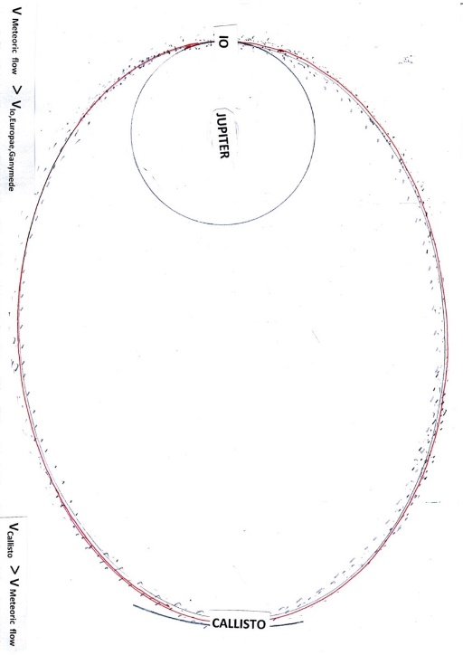

**Fig. 2. Schematic picture**

Callisto is gathering on and overtaking meteor showers, which bombard it from the front side due to the fact that the majority of meteoric bodies are dark (have less albedo and a high degree of polarization).

Consequently, the light, reflected from the satellite’s indicated side corresponds to the higher degree of polarization. As the mentioned effect lasts for billions of years, the satellite’s front and rear sides differ from each other.

**IV.Conclusion**

The obtained results confirm that the surfaces of the Galilean moons moving synchronously around Jupiter are non-uniform, among them Europa has a relatively uniform surface, while Callisto has the most non-uniform surface, Io's surface undergoes the most changes over time.

Based on the analysis of the observed material, we are also convinced that the front hemispheres of the Galilean moons (Io, Europa, Ganymede) that are relatively close to Jupiter (due to their movement) have the ability to reflect the light falling on them more than the rear hemispheres, and Callisto, which is far from Jupiter, on the contrary, is one of the reasons for this fact. - One explanation is given in the presented work.

**References**

1. R.A. Chigladze, M.L. Tateshvili, “Results of Observations over Jupiter's Galilean satellites”, Astronomy & Astrophysics (Caucasus) 2018, 3, 23-29.
2. V.K. Rosenbush., N.N Kiselev., “Polarization opposition effect for the Galilean satellites of Jupiter”. Icarus 2005,179, 2, 490-496.
3. N.N. Kiselev, et al. “New Polarimetric Data for the Galilean Satellites: Europa Observations and Modeling”. The Planetary Science Journal, 2022.Volume 3, Issue 6, id.134, 13 pp.
4. D.D. Morrison, N.D. Morrison, “Planetary Satellites. Photometry of the Galilean satellites”, Proceedings of IAU Colloq. 28, held in Ithaca, NY, August 1974. Edited by J. A. Burns. University of Arizona Press, 1977, p.363.
5. A.A. Dolfus. “Optical polarimetry of the Galilean satellites of Jupiter”. Icarus 1975,25, p.416-431.
6. A.K. Sergei, “Basic Celestial Mechanics”. Technische Universität Dresden, 2016.